Data mining:
>Data mining refers to the process of discovering insights, patterns, and knowledge from large data.
>It involves using techniques from fields such as statistics, machine learning, and artificial intelligence
to extract insights and knowledge from data.
>Data mining can be applied to a wide variety of fields, including business, finance, healthcare, and
Concept Hierarchy in Data Mining
>In data mining, the concept of a concept hierarchy refers to the organization of data into a tree-like
structure, where each level of the hierarchy represents a concept that is more general than the level
below it
> The concept of hierarchy is used to organize and classify data in a way that makes it more
understandable and easier to analyze.
> The main idea behind the concept of hierarchy is that the same data can have different levels of
granularity or levels of detail and that by organizing the data in a hierarchical fashion, it is easier to
understand and perform analysis.

Explanation:
As shown in the above diagram, it consists of a concept hierarchy for the dimension location, where the user can easily retrieve the data. In order to evaluate it easily the data is represented in a tree-like structure. The top of the tree consists of the main dimension location and further splits into various sub-nodes. The root node is located, and it further splits into two nodes countries ie. USA and India. These countries are further then splitted into more sub-nodes, that represent the province states ie. New York, Illinois, Gujarat, UP. Thus the concept hierarchy as shown in the above example organizes the data into a tree-like structure and describes and represents in more general than the level below it.
The hierarchical structure represents the abstraction level of the dimension location, which consists of various footprints of the dimension such as street, city, province state, and country.

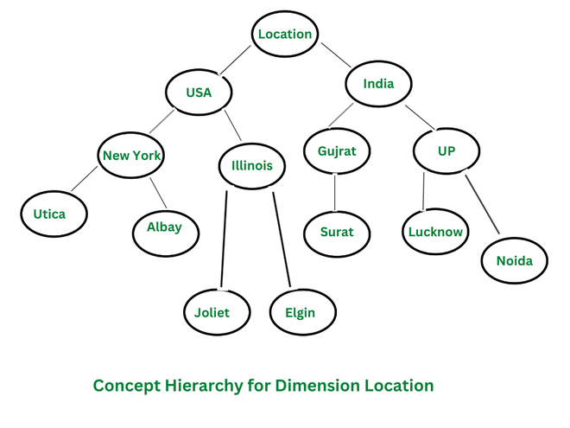

Types of Concept Hierarchies
- Schema Hierarchy: Schema Hierarchy is a type of concept hierarchy that is used to organize the schema of a database in a logical and meaningful way, grouping similar objects together. A schema hierarchy can be used to organize different types of data, such as tables, attributes, and relationships, in a logical and meaningful way. This can be useful in data warehousing, where data from multiple sources needs to be integrated into a single database

- Set-Grouping Hierarchy: Set-Grouping Hierarchy is a type of concept hierarchy that is based on set theory, where each set in the hierarchy is defined in terms of its membership in other sets. Set-grouping hierarchy can be used for data cleaning, data pre-processing and data integration. This type of hierarchy can be used to identify and remove outliers, noise, or inconsistencies from the data and to integrate data from multiple sources

- Operation-Derived Hierarchy: An Operation-Derived Hierarchy is a type of concept hierarchy that is used to organize data by applying a series of operations or transformations to the data. The operations are applied in a top-down fashion, with each level of the hierarchy representing a more general or abstract view of the data than the level below it. This type of hierarchy is typically used in data mining tasks such as clustering and dimensionality reduction. The operations applied can be mathematical or statistical operations such as aggregation, normalization
- Rule-based Hierarchy: Rule-based Hierarchy is a type of concept hierarchy that is used to organize data by applying a set of rules or conditions to the data. This type of hierarchy is useful in data mining tasks such as classification, decision-making, and data exploration. It allows to the assignment of a class label or decision to each data point based on its characteristics and identifies patterns and relationships between different attributes of the data.

Need of Concept Hierarchy in Data Mining
There are several reasons why a concept hierarchy is useful in data mining:
- Improved Data Analysis: A concept hierarchy can help to organize and simplify data, making it more manageable and easier to analyze.

- Improved Data Visualization and Exploration: A concept hierarchy can help to improve data visualization and data exploration by organizing data into a tree-like structure, allowing users to easily navigate and understand large and complex data sets.

- Improved Algorithm Performance: The use of a concept hierarchy can also help to improve the performance of data mining algorithms. By organizing data into a hierarchical structure, algorithms can more easily process and analyze the data, resulting in faster and more accurate results.
- Data Cleaning and Pre-processing: A concept hierarchy can also be used in data cleaning and pre-processing, to identify and remove outliers and noise from the data.
- Domain Knowledge: A concept hierarchy can also be used to represent the domain knowledge in a more structured way, which can help in a better understanding of the data and the problem domain.

Applications of Concept Hierarchy
>Data Warehousing
> Business Intelligence
>Online Retail
>Health care
> Natural Language Processing
Conclusion
A concept hierarchy is a process in data mining that can help to organize and simplify large and complex data sets. It improves data visualization, algorithm performance, and data cleaning and pre-processing. The concept hierarchy can be applied in various fields, such as data warehousing, business intelligence, online retail, healthcare, natural language processing, and fraud detection among others.

